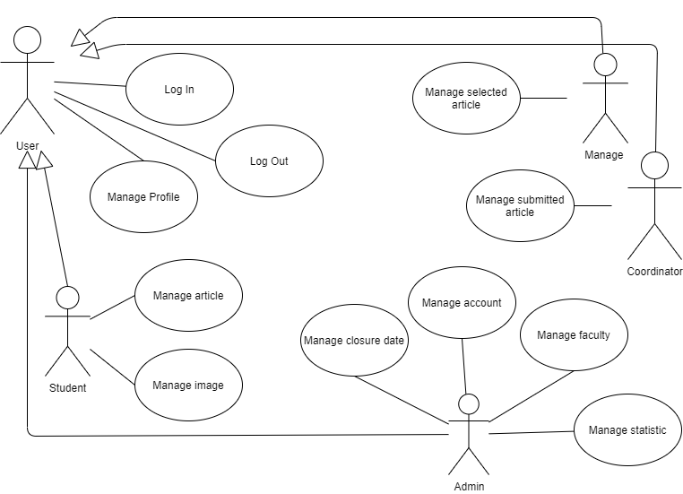

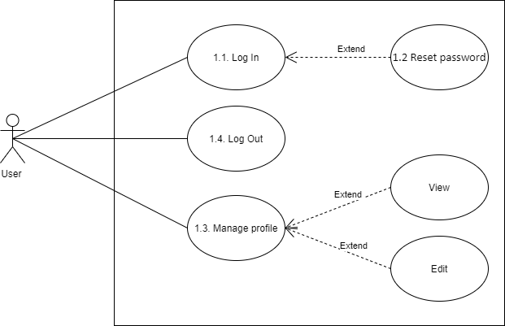

|  |  |  |
| --- | --- | --- |
| Use Case Identification and History | | |
| **Use Case ID:** | | 1.1 |
| **Use Case Name:** | | Log in |
| **Description:** | | As the user, I want to log into the app to perform system functions |
| **User/Actor:** | | User |
| **Trigger:** | | The user want to logged into the system |
| Pre-conditions | | | |
| The user already has an account.  The user’s device was connected to the internet when logging in. | | | |
| **Basic Flow: The user login successfully.** | | | |
| **Step** | **Actions** | | |
| **1** | User access to the website . | | |
| **2** | User enter information to login. | | |
| **3** | User click login button. | | |
| **4** | The system verifies login information and allows users to access the website. | | |
| **Exception Flow: The user cannot login.** | | | |
| **1** | The user entered missing information. | | |
| **1a** | The system reports that the user enters missing information.  (Return step 2 in Basic Flow) | | |
| **2** | The user entered incorrectly less than five times. | | |
| **2a** | The system reports that the user enters incorrect information.  (Return step 2 in Basic Flow) | | |
| Post conditions | | | |
| The user has successfully logged in to the application | | | |
| Business Rules | | | |
| Users who enter incorrect login information for the 5th consecutive time will be locked out of their account. | | | |

|  |  |
| --- | --- |
| Use Case Identification and History | |
| **Use Case ID:** | 1.2 |
| **Use Case Name:** | Reset password |
| **Description:** | As the user, I forget the password and want to create new password. |
| **User/Actor:** | User |
| **Trigger:** | The user forget password. |
| Pre-conditions | | |
| The user already has an account and information of email.  The user’s device was connected to the internet. | | |

| **Basic Flow: The user reset password successfully.** | |
| --- | --- |
| **Step** | **Actions** |
| **1** | User access to the website. |
| **2** | User click link forget password. |
| **3** | User enter your username. |
| **4** | User reconfirms his email. |
| **5** | The system will send a message to his email. |
| **6** | User go to email and open the message. |
| **7** | User click link in message and enter new password. |
| **Exception Flow:** **The user cannot reset password.** | |
| **1** | The user entered wrong username or email. |
| **1a** | The system reports that the user enters wrong information.  (Return step 3 in Basic Flow) |
| **2** | The user cannot be received email. |
| **2a** | Retry all step in Basic Flow. |
| **2b** | If you until don’t received email, you need to contact with admin. |
| Post conditions | |
| The user has successfully logged in to the application. | |

|  |  |  |
| --- | --- | --- |
| Use Case Identification and History | | |
| **Use Case ID:** | | 1.3 |
| **Use Case Name:** | | Manage Profile |
| **Description:** | | All users can manage their profiles. |
| **User/Actor:** | | User |
| **Trigger:** | | Users want to manage their profiles. |
| Pre-conditions | | | |
| User logged into the system.  Webpage is displayed successfully. | | | |
| **Basic Flow: The user edit the profile successfully.** | | | |
| **Step** | **User Actions** | | |
| **1** | User choose button my profile. | | |
| **2** | The system will display a profile of user frame. | | |
| **3** | User fill in the information they want to change and choose the modify command. | | |
| **4** | The system saves information in database and displays recorded information.. | | |
| **Alternative Flow: The user view profile.** | | | |
| **3a** | The user will view a profile of them. | | |
| **Exception Flow: The user cannot edit profile** | | | |
| **1** | The user cannot enter new information. | | |
| **1a** | The user refresh the website and re-enters the information.  (Use case cotinue step 4) | | |

|  |  |  |
| --- | --- | --- |
| Use Case Identification and History | | |
| **Use Case ID:** | | 1.4 |
| **Use Case Name:** | | Log out |
| **Description:** | | User log out the website. |
| **User/Actor:** | | User |
| **Trigger:** | | Users want to log out. |
| Pre-conditions | | | |
| User logged into the system.  Webpage is displayed successfully. | | | |
| **Basic Flow: The user log out successfully.** | | | |
| **Step** | **User Actions** | | |
| **1** | User click button logout. | | |
| **2** | The system will display a login page. | | |
| **Exception Flow: The user can’t log out.** | | | |
| **Step** | **User Actions** | | |
| **1** | User click button logout.  (System does not display login page) | | |
| **2** | Reload website and try logout again.  (Use case stop) | | |

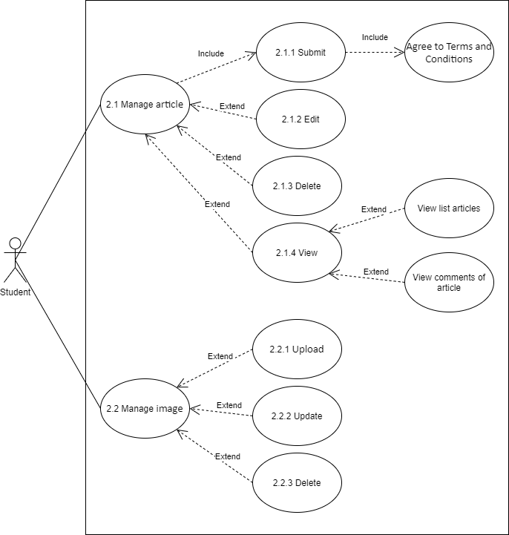

|  |  |  |
| --- | --- | --- |
| Use Case Identification and History | | |
| **Use Case ID:** | | 2.1.1 |
| **Use Case Name:** | | Submit acticle. |
| **Description:** | | Student will submit article on website. |
| **User/Actor:** | | Student |
| **Trigger:** | | Student want to submit acticle. |
| Pre-conditions | | | |
| Student is logged into the system  Webpage is displayed successfully | | | |
| **Basic Flow: Student submit the acticles successfully.** | | | |
| **Step** | **Action** | | |
| **1** | Student choose upload article in menu. | | |
| **2** | The system will display the upload form. | | |
| **3** | Student choose file to upload. | | |
| **4** | Student will read Term and Condition and argee it. | | |
| **5** | Student click submit button. | | |
| **6** | The article display in list. | | |
| Exception Flow: Student cannot submit article | | | |
| **1** | The student cannot upload file. | | |
| **2** | Check if the file is valid. | | |
| **3** | Save the file name or save it as another file  (Retutn step 3 in Basic flow) | | |

|  |  |  |
| --- | --- | --- |
| Use Case Identification and History | | |
| **Use Case ID:** | | 2.1.4 |
| **Use Case Name:** | | View about acticle. |
| **Description:** | | Student will view list article or comments of article. |
| **User/Actor:** | | Student |
| **Trigger:** | | Student want to view acticle. |
| Pre-conditions | | | |
| Student is logged into the system  Webpage is displayed successfully | | | |
| **Basic Flow: Student view list the acticles.** | | | |
| **Step** | **Action** | | |
| **1** | Student choose my responsity in menu. | | |
| **2** | The system will display the list article. | | |
| **Alternative Flow: Student view list the comment of article.** | | | |
| **Step** | **Action** | | |
| **1** | Student choose my responsity in menu. | | |
| **2** | The system will display the list article. | | |
| **3** | Student choosee article | | |
| **4** | Display the list comments of article | | |
| **Alternative Flow: Student view comments of acticle.** | | | |
| **Step** | **Action** | | |
| **1** | (Continue step 2 in Basic flow)  Student choose the article that he want to view comment. | | |
| **2** | The system will display the list comments. | | |

|  |  |  |
| --- | --- | --- |
| Use Case Identification and History | | |
| **Use Case ID:** | | 2.1.2 |
| **Use Case Name:** | | Edit acticle. |
| **Description:** | | Student will edit article. |
| **User/Actor:** | | Student |
| **Trigger:** | | The article needs to change. |
| Pre-conditions | | | |
| Student is logged into the system  Webpage is displayed successfully | | | |
| **Basic Flow: Student edit acticles successfully.** | | | |
| **Step** | **Action** | | |
| **1** | Student choose my responsity in menu. | | |
| **2** | The system will display the list article. | | |
| **3** | Student click edit button in that article. | | |
| **4** | Student rename or reupload article. | | |
| **5** | Student click save change | | |
| **6** | The system save in database and alerts saved changes. | | |
| **Exception Flow: The article don’t change after edit.** | | | |
| **Step** | **Action** | | |
| **1** | Reload the website. | | |
| **2** | Repeat the steps in basic flow. | | |
| **3** | If the article until doesn’t change, student will report with admin. | | |

|  |  |  |
| --- | --- | --- |
| Use Case Identification and History | | |
| **Use Case ID:** | | 2.1.3 |
| **Use Case Name:** | | Delete acticle. |
| **Description:** | | Student will delete article. |
| **User/Actor:** | | Student |
| **Trigger:** | | The article needs to remove. |
| Pre-conditions | | | |
| Student is logged into the system  Webpage is displayed successfully | | | |
| **Basic Flow: Student delete acticles successfully.** | | | |
| **Step** | **Action** | | |
| **1** | Student choose my responsity in menu. | | |
| **2** | The system will display the list article. | | |
| **3** | Student click delete button in that article. | | |
| **4** | The article will remove from the list. | | |
| **Exception Flow: The article isn’t removed fromt the list.** | | | |
| **Step** | **Action** | | |
| **1** | Reload the website. | | |
| **2** | Repeat all step in basic flow. | | |
| **3** | If still do not, student will report with admin. | | |

|  |  |  |
| --- | --- | --- |
| Use Case Identification and History | | |
| **Use Case ID:** | | 2.2.1 |
| **Use Case Name:** | | Upload image |
| **Description:** | | Student will upload image for article. |
| **User/Actor:** | | Student |
| **Trigger:** | | The article needs to description image. |
| Pre-conditions | | |
| Student is logged into the system  Webpage is displayed successfully | | |
| **Basic Flow: Student upload image successfully.** | | |
| **Step** | **Action** | |
| **1** | Student choose my reposity in menu. | |
| **2** | The system will display the list article. | |
| **3** | Student choose button edit article. | |
| **4** | The system display the page of article. | |
| **5** | Student will button upload image. | |
| **6** | Student choose image in floder to upload. | |
| **7** | Student choose command upload. | |
| Exception Flow: Image cannot be uploaded. | | |
| **1** | Reload the website. | |
| **2** | Repeat all step in basic flow. | |
| **3** | If still do not, student will report with admin. | |

|  |  |  |
| --- | --- | --- |
| Use Case Identification and History | | |
| **Use Case ID:** | | 2.2.2 |
| **Use Case Name:** | | Update image |
| **Description:** | | Student will update image for article. |
| **User/Actor:** | | Student |
| **Trigger:** | | The article needs to change. |
| Pre-conditions | | |
| Student is logged into the system  Webpage is displayed successfully | | |
| **Basic Flow: Student update image successfully.** | | |
| **Step** | **Action** | |
| **1** | Student choose my reposity in menu. | |
| **2** | The system will display the list article. | |
| **3** | Student choose button edit article. | |
| **4** | The system display the page of article. | |
| **5** | Student will button update image. | |
| **6** | Student choose image in floder to update. | |
| **7** | Student choose command update. | |
| Exception Flow: Image cannot be updated. | | |
| **1** | Reload the website. | |
| **2** | Repeat all step in basic flow. | |
| **3** | If the image until doesn’t change, student will report with admin. | |

|  |  |  |
| --- | --- | --- |
| Use Case Identification and History | | |
| **Use Case ID:** | | 2.2.3 |
| **Use Case Name:** | | Delete image |
| **Description:** | | Student will delete image for article. |
| **User/Actor:** | | Student |
| **Trigger:** | | The article needs to delete. |
| Pre-conditions | | |
| Student is logged into the system  Webpage is displayed successfully | | |
| **Basic Flow: Student delete** **image successfully.** | | |
| **Step** | **Action** | |
| **1** | Student choose my reposity in menu. | |
| **2** | The system will display the list article. | |
| **3** | Student choose button edit article. | |
| **4** | The system display the page of article. | |
| **5** | Student choose command delete image. | |
| Exception Flow: Image cannot be deleted. | | |
| **1** | Reload the website. | |
| **2** | Repeat all step in basic flow. | |
| **3** | If still do not, student will report with admin. | |

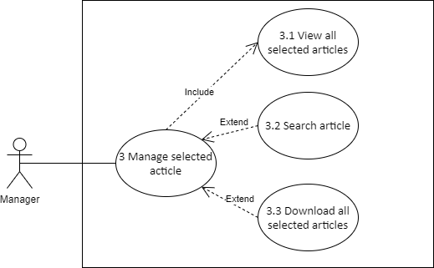

|  |  |  |
| --- | --- | --- |
| Use Case Identification and History | | |
| **Use Case ID:** | | 3.1 |
| **Use Case Name:** | | View article |
| **Description:** | | Manage will view selected article. |
| **User/Actor:** | | Manage |
| **Trigger:** | | Manage want to view article. |
| Pre-conditions | | |
| Manage is logged into the system  Webpage is displayed successfully | | |
| **Basic Flow: Manage view article successfully.** | | |
| **Step** | **Action** | |
| **1** | Manage choose view contribute. | |
| **2** | Manage will choose contribute. | |
| **3** | The system will display the list article. | |
| Exception Flow: Manage cannot view article. | | |
| **1** | Reload the website. | |
| **2** | Repeat all step in basic flow. | |
| **3** | If still do not, manage will report with admin. | |

|  |  |  |
| --- | --- | --- |
| Use Case Identification and History | | |
| **Use Case ID:** | | 3.2 |
| **Use Case Name:** | | Searh article |
| **Description:** | | Manage will search article. |
| **User/Actor:** | | Manage |
| **Trigger:** | | Manage want to search article. |
| Pre-conditions | | |
| Manage is logged into the system  Webpage is displayed successfully | | |
| **Basic Flow: Manage search article successfully.** | | |
| **Step** | **Action** | |
| **1** | Manage choose view contribute. | |
| **2** | Manage will choose the faculty. | |
| **3** | The system will display the list article | |
| **4** | Manage enter information of article on search box and click button search. | |
| **5** | The article will display. | |
| Exception Flow: Manage cannot search article. | | |
| **1** | Reload the website. | |
| **2** | Repeat all step in basic flow. | |
| **3** | If still do not, manage will report with admin. | |

|  |  |  |
| --- | --- | --- |
| Use Case Identification and History | | |
| **Use Case ID:** | | 3.3 |
| **Use Case Name:** | | Download all articles |
| **Description:** | | Manage will download all article. |
| **User/Actor:** | | Manage |
| **Trigger:** | | Manage want to public magazine. |
| Pre-conditions | | |
| Manage is logged into the system  Webpage is displayed successfully | | |
| **Basic Flow: Manage download all article successfully.** | | |
| **Step** | **Action** | |
| **1** | Manage choose view contribute. | |
| **2** | Manage will choose the faculty. | |
| **3** | The system will display the list article | |
| **4** | Click button download all article. | |
| **5** | All articles are downloaded to your computer as zip files. | |
| Exception Flow: All article cannot be downloaded. | | |
| **1** | Reload the website. | |
| **2** | Repeat all step in basic flow. | |
| **3** | If still do not, manage will report with admin. | |

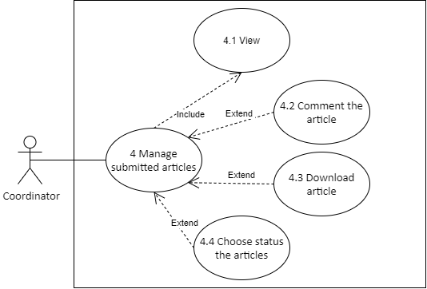

|  |  |  |
| --- | --- | --- |
| Use Case Identification and History | | |
| **Use Case ID:** | | 4.1 |
| **Use Case Name:** | | View article |
| **Description:** | | Coordinator will view submitted article. |
| **User/Actor:** | | Coordinator |
| **Trigger:** | | Coordinator want to view article. |
| Pre-conditions | | |
| Coordinator is logged into the system  Webpage is displayed successfully | | |
| **Basic Flow: Coordinator view article successfully.** | | |
| **Step** | **Action** | |
| **1** | Coordinator choose contribute in menu. | |
| **2** | The system will display the list article. | |
| Exception Flow: Coordinator cannot view article. | | |
| **1** | Reload the website. | |
| **2** | Repeat all step in basic flow. | |
| **3** | If still do not, coordinator will report with admin. | |

|  |  |  |
| --- | --- | --- |
| Use Case Identification and History | | |
| **Use Case ID:** | | 4.2 |
| **Use Case Name:** | | Comment article |
| **Description:** | | Coordinator will comment for article. |
| **User/Actor:** | | Coordinator |
| **Trigger:** | | Coordinator want to comment article. |
| Pre-conditions | | |
| Coordinator is logged into the system  Webpage is displayed successfully | | |
| **Basic Flow: Coordinator view article successfully.** | | |
| **Step** | **Action** | |
| **1** | Coordinator choose contribute in menu. | |
| **2** | The system will display the list article. | |
| **3** | Coordinator click article that he want to comment. | |
| **4** | Enter comment and button send. | |
| Exception Flow: Comment don’t display. | | |
| **1** | Reload the website. | |
| **2** | Repeat all step in basic flow. | |
| **3** | If still do not, coordinator will report with admin. | |

|  |  |  |
| --- | --- | --- |
| Use Case Identification and History | | |
| **Use Case ID:** | | 4.3 |
| **Use Case Name:** | | Download article |
| **Description:** | | Coordinator will download article. |
| **User/Actor:** | | Coordinator |
| **Trigger:** | | Coordinator want to read article. |
| Pre-conditions | | |
| Coordinator is logged into the system  Webpage is displayed successfully | | |
| **Basic Flow: Coordinator download article successfully.** | | |
| **Step** | **Action** | |
| **1** | Coordinator choose contribute in menu. | |
| **2** | The system will display the list article. | |
| **3** | Coordinator click article that he want to read. | |
| **4** | Choose download button. | |
| Exception Flow: Article isn’t downloaded. | | |
| **1** | Reload the website. | |
| **2** | Repeat all step in basic flow. | |
| **3** | If still do not, coordinator will report with admin. | |

|  |  |  |
| --- | --- | --- |
| Use Case Identification and History | | |
| **Use Case ID:** | | 4.4 |
| **Use Case Name:** | | Select status |
| **Description:** | | Coordinator will select status for article. |
| **User/Actor:** | | Coordinator |
| **Trigger:** | | Coordinator want to determine for article. |
| Pre-conditions | | |
| Coordinator is logged into the system  Webpage is displayed successfully | | |
| **Basic Flow: Coordinator selects status successfully.** | | |
| **Step** | **Action** | |
| **1** | Coordinator choose contribute in menu. | |
| **2** | The system will display the list article. | |
| **3** | Coordinator move the mouse to status of article and select status. | |
| Exception Flow: Coordinator cannot select status. | | |
| **1** | Reload the website. | |
| **2** | Repeat all step in basic flow. | |
| **3** | If still do not, coordinator will report with admin. | |

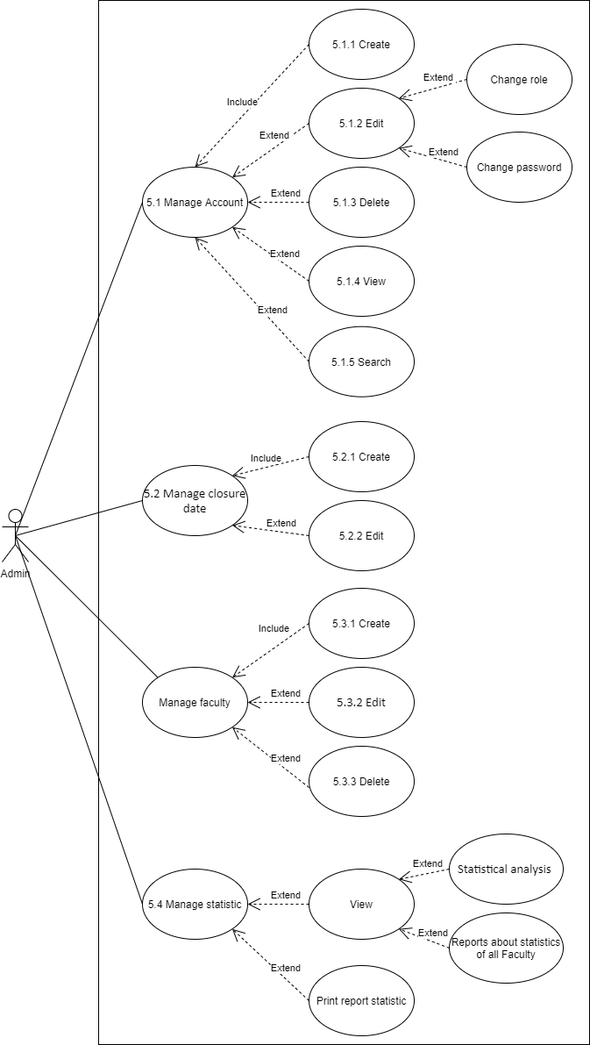

|  |  |  |
| --- | --- | --- |
| Use Case Identification and History | | |
| **Use Case ID:** | | 5.1.1 |
| **Use Case Name:** | | Create account |
| **Description:** | | Admin will create account. |
| **User/Actor:** | | Admin |
| **Trigger:** | | Having new user. |
| Pre-conditions | | |
| Admin is logged into the system  Webpage is displayed successfully | | |
| **Basic Flow: Admin create account successfully.** | | |
| **Step** | **Action** | |
| **1** | Admin will choose add user in menu | |
| **2** | Admin will select role for new user and click add. | |
| **3** | The system display form to create. | |
| **4** | Admin fills information for new user. | |
| **5** | After, admin choose button add. | |
| **6** | User will display in list. | |
| Exception Flow: Account don’t display in list. | | |
| **1** | Reload the website. | |
| **2** | Repeat all step in basic flow. | |

|  |  |  |
| --- | --- | --- |
| Use Case Identification and History | | |
| **Use Case ID:** | | 5.1.2 |
| **Use Case Name:** | | Edit account |
| **Description:** | | Admin will edit account. |
| **User/Actor:** | | Admin |
| **Trigger:** | | Infomation of user needs to be changed. |
| Pre-conditions | | |
| Admin is logged into the system  Webpage is displayed successfully | | |
| **Basic Flow: Admin edit account successfully.** | | |
| **Step** | **Action** | |
| **1** | Admin will choose view user in menu | |
| **2** | Admin will select role for user and click view. | |
| **3** | The system display list user of that role. | |
| **4** | Admin choose user want to edit and click button read more. | |
| **5** | Admin change information and click modify. | |
| **6** | The system change information in database and successful change notification. | |
| Exception Flow: Information of user does not change. | | |
| **1** | Reload the website. | |
| **2** | Repeat all step in basic flow. | |

|  |  |  |
| --- | --- | --- |
| Use Case Identification and History | | |
| **Use Case ID:** | | 5.1.3 |
| **Use Case Name:** | | Delete account |
| **Description:** | | Admin will delete account. |
| **User/Actor:** | | Admin |
| **Trigger:** | | User does not exsist. |
| Pre-conditions | | |
| Admin is logged into the system  Webpage is displayed successfully | | |
| **Basic Flow: Admin delete account successfully.** | | |
| **Step** | **Action** | |
| **1** | Admin will choose view user in menu | |
| **2** | Admin will select role for user and click view. | |
| **3** | The system display list user of that role. | |
| **4** | Admin choose user want to delete and click button read more. | |
| **5** | Admin click delete button. | |
| **6** | User will remove from to list. | |
| Exception Flow: User cannot remove form list. | | |
| **1** | Reload the website. | |
| **2** | Repeat all step in basic flow. | |

|  |  |  |
| --- | --- | --- |
| Use Case Identification and History | | |
| **Use Case ID:** | | 5.1.4 |
| **Use Case Name:** | | View account |
| **Description:** | | Admin will view account. |
| **User/Actor:** | | Admin |
| **Trigger:** | | Admin want to know information of user. |
| Pre-conditions | | |
| Admin is logged into the system  Webpage is displayed successfully | | |
| **Basic Flow: Admin view account successfully.** | | |
| **Step** | **Action** | |
| **1** | Admin will choose view user in menu | |
| **2** | Admin will select role for user and click view. | |
| **3** | The system display list user of that role. | |
| **4** | Admin choose user want to view and click button read more. | |

|  |  |  |
| --- | --- | --- |
| Use Case Identification and History | | |
| **Use Case ID:** | | 5.1.4 |
| **Use Case Name:** | | Search account |
| **Description:** | | Admin will search account. |
| **User/Actor:** | | Admin |
| **Trigger:** | | Admin want to find user. |
| Pre-conditions | | |
| Admin is logged into the system  Webpage is displayed successfully | | |
| **Basic Flow: Admin search account successfully.** | | |
| **Step** | **Action** | |
| **1** | Admin will choose view user in menu | |
| **2** | Admin will select role for user and click view. | |
| **3** | The system display list user of that role. | |
| **4** | Admin enter information of user in search box. | |
| **5** | Admin click search button. | |
| **6** | The system display that user | |
| Exception Flow: User does not display form list. | | |
| **1** | Reload the website. | |
| **2** | Repeat all step in basic flow. | |

|  |  |  |
| --- | --- | --- |
| Use Case Identification and History | | |
| **Use Case ID:** | | 5.2.1 |
| **Use Case Name:** | | Set time |
| **Description:** | | Admin set the closure date and final closure date. |
| **User/Actor:** | | Admin |
| **Trigger:** | | Set time for each year to student submiting article. |
| Pre-conditions | | |
| Admin is logged into the system  Webpage is displayed successfully | | |
| **Basic Flow: Admin set time successfully.** | | |
| **Step** | **Action** | |
| **1** | Admin will choose set closure date in menu. | |
| **2** | Display form. | |
| **3** | Admin will select time for closure date and final closure date. | |
| **4** | Admin click button save. | |
|  | The date display in list. | |
| Exception Flow: The date don’t display in list. | | |
| **1** | Reload the website. | |
| **2** | Repeat all step in basic flow. | |

|  |  |  |
| --- | --- | --- |
| Use Case Identification and History | | |
| **Use Case ID:** | | 5.2.2 |
| **Use Case Name:** | | Edit time |
| **Description:** | | Admin edit the closure date or final closure date. |
| **User/Actor:** | | Admin |
| **Trigger:** | | Edit time for each year to student submiting article. |
| Pre-conditions | | |
| Admin is logged into the system  Webpage is displayed successfully | | |
| **Basic Flow: Admin edit time successfully.** | | |
| **Step** | **Action** | |
| **1** | Admin will choose view closure date in menu. | |
| **2** | Admin will select date to edit. | |
| **3** | The system display form to edit. | |
| **4** | Admin click button save. | |
| **5** | The date display in list. | |
| Exception Flow: The date don’t display in list. | | |
| **1** | Reload the website. | |
| **2** | Repeat all step in basic flow. | |

|  |  |  |
| --- | --- | --- |
| Use Case Identification and History | | |
| **Use Case ID:** | | 5.3.1 |
| **Use Case Name:** | | Create faculty |
| **Description:** | | Admin will create faculty. |
| **User/Actor:** | | Admin |
| **Trigger:** | | Having new faculty. |
| Pre-conditions | | |
| Admin is logged into the system  Webpage is displayed successfully | | |
| **Basic Flow: Admin create faculty successfully.** | | |
| **Step** | **Action** | |
| **1** | Admin will choose add faculty in menu | |
| **2** | Admin click button add. | |
| **3** | The system display form to create. | |
| **4** | Admin fills information. | |
| **5** | After, admin choose button add. | |
| **6** | Faculty will display in list. | |
| Exception Flow: Faculty don’t display in list. | | |
| **1** | Reload the website. | |
| **2** | Repeat all step in basic flow. | |

|  |  |  |
| --- | --- | --- |
| Use Case Identification and History | | |
| **Use Case ID:** | | 5.3.2 |
| **Use Case Name:** | | Edit faculty |
| **Description:** | | Admin will edit faculty. |
| **User/Actor:** | | Admin |
| **Trigger:** | | Information of faculty incorrect. |
| Pre-conditions | | |
| Admin is logged into the system  Webpage is displayed successfully | | |
| **Basic Flow: Admin edit faculty successfully.** | | |
| **Step** | **Action** | |
| **1** | Admin will choose view faculty in menu | |
| **2** | Admin click button edit. | |
| **3** | The system display form. | |
| **4** | Admin change information. | |
| **5** | After, admin choose button save. | |
| **6** | The system change information in database and successful change notification. | |
| Exception Flow: Information of faculty not change. | | |
| **1** | Reload the website. | |
| **2** | Repeat all step in basic flow. | |

|  |  |  |
| --- | --- | --- |
| Use Case Identification and History | | |
| **Use Case ID:** | | 5.3.2 |
| **Use Case Name:** | | Delete faculty |
| **Description:** | | Admin will deletet faculty. |
| **User/Actor:** | | Admin |
| **Trigger:** | | Faculty does not exsist in university. |
| Pre-conditions | | |
| Admin is logged into the system  Webpage is displayed successfully | | |
| **Basic Flow: Admin delete faculty successfully.** | | |
| **Step** | **Action** | |
| **1** | Admin will choose view faculty in menu | |
| **2** | Admin click button delete. | |
| **3** | Faculty remove from list. | |
| Exception Flow: Faculty does not disappear. | | |
| **1** | Reload the website. | |
| **2** | Repeat all step in basic flow. | |

|  |  |  |
| --- | --- | --- |
| Use Case Identification and History | | |
| **Use Case ID:** | | 5.4 |
| **Use Case Name:** | | Manage statistic |
| **Description:** | | Admin manage statistic such as view and print it. |
| **User/Actor:** | | Admin |
| **Trigger:** | | Admin want to manage statistic |
| Pre-conditions | | |
| Admin is logged into the system  Webpage is displayed successfully | | |
| **Basic Flow: Admin view statistic successfully.** | | |
| **Step** | **Action** | |
| **1** | Admin will choose view statistic in menu. | |
| **2** | The system will display statistic according to each year. | |
| **Basic Flow: Admin view report statistic successfully.** | | |
| **Step** | **Action** | |
| **1** | Admin will choose view report in menu. | |
| **2** | The system will display report statistic. | |
| **Basic Flow: Admin print report statistic successfully.** | | |
| **Step** | **Action** | |
| **1** | Admin will choose view statistic in menu. | |
| **2** | The system will display statistic according to each year. | |
| **3** | Admin choose print report. | |
| **4** | The system will print report into paper. | |
| Exception Flow: Admin does not view. | | |
| **1** | Reload the website. | |
| **2** | Repeat all step in basic flow. | |